**RALLY CAR DESIGN CHALLENGE**

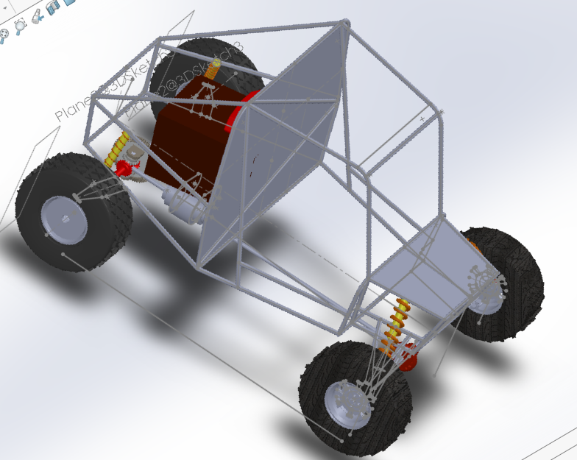

**DATE: 04/10/2017**

**EVENT: RALLY CAR DESIGN CHALLENGE**

**INSTRUCTOR: SRIPAD DIWAKAR**

**TEAM MEMBERS: DIVYAM GARG (CAPTAIN)**

**ARJUN DEV SIKHWAL (VICE-CAPTAIN)**

**SAMRUDH U.P (POWER-TRAIN HEAD)**

**ANUROOP SHOWRI (BRAKE HEAD)**

**SACHIN KUMAR SINGH (SUSPENSION HEAD)**

**GIRISH NANJUNDA (MARKETING HEAD)**

**CHANUKYA PUPPALA (STEERING HEAD)**

**Assembly**

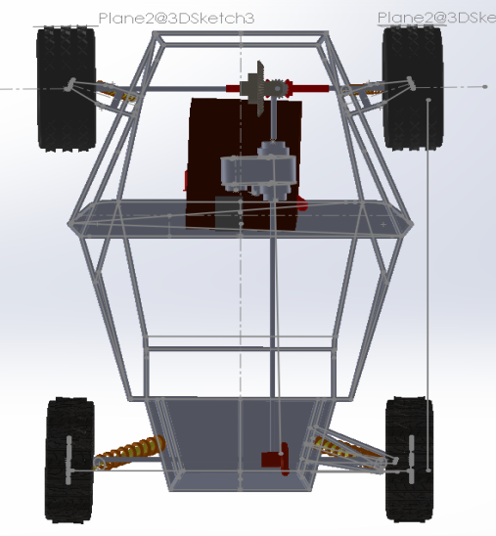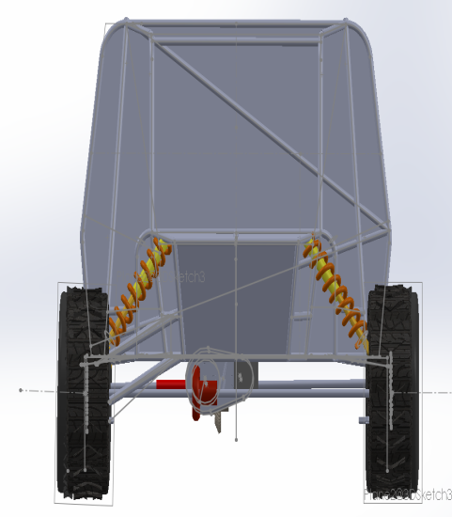

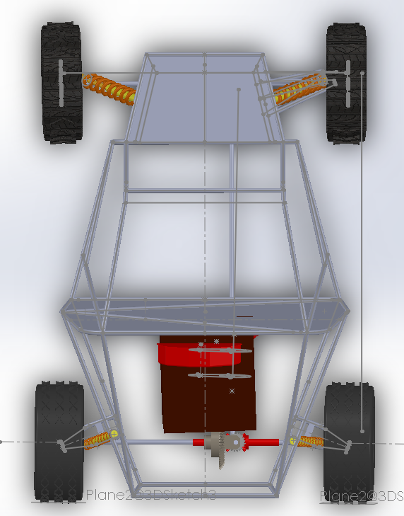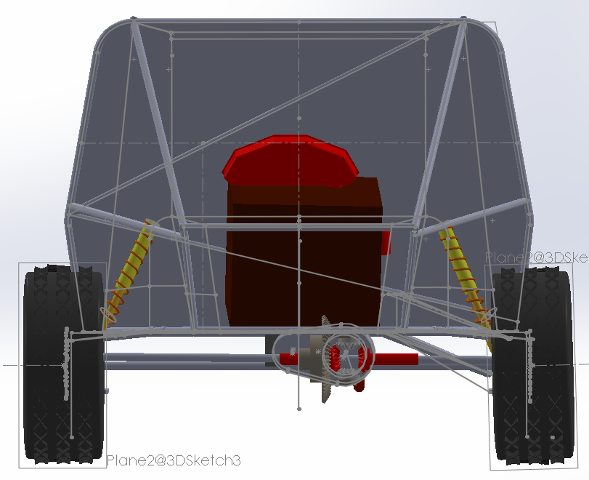

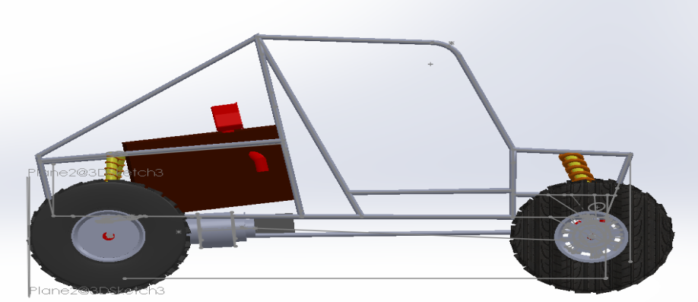

**EXECUTIVE SUMMARY**

**Rally car design challenge (RCDC)**

There is a need in OUR COUNTRY for a large selection of quality of rally cars, and RCDC is the best platform to capture the true potential in the young minds in improvising the already established esteemed off road sport .This is India’s first challenge in which engineering students will be coming in contact and participating with professional motorsports people.

We ,The Automates ,have put our heart and soul in this to bestow the best .we have used best in class modules in our vehicle ,its efficient design , materials and structure according to the specified standards is the testament that we are going to be successful ,with the cost being kept in mind.

**Process**

* First of all we have designed the framework using solid works 2017 in proportion to the specified standards

* Then we proceeded with the selection of wheels and assembled them eventually with the firm calculations of the former.

* Thereafter, we went on with the design of suspension and was tested and analyzed in the solid works simulation , for errors and failures

* Further with the specified range of loads allowed and other values we designed and perpetrated the required calculations of steering, braking system ,spring system and others.

* Finally we assembled all our deigned parts accordingly and analyzed if its working up to the mark.

With the results obtained from testing our fully assembled design, we are sanguine about the performance of the vehicle and its capabilities in off-roading.

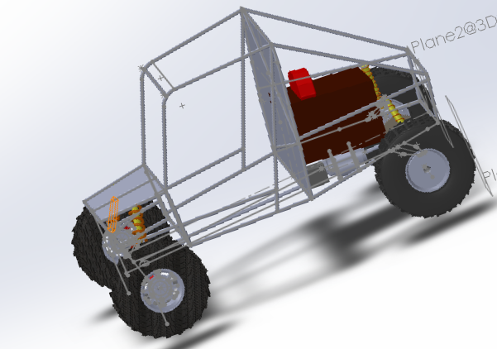

**Table Of Contents**

|  |  |
| --- | --- |
| Topic | Page number |
| Design Problems | 1 |
| Objectives | 2 |
| Detailed Design Documentation | 3 |
| Chassis | 4 |
| Technical Specifications | 5 |
| Suspensions | 6 |
| Braking | 7 |
| Steering | 8 |
| Power Train | 8 |
| Safety | 9 |
| Conclusion | 10 |
| Acknowledgments | 11 |
| Annexure | 12 |

**Design Problems**

**1. In Frame work :**

A )Assuming the required different values of lengths etc. to finally meet the specified standards

b) In determining factor of safety

**2. In Suspension :**

a)Front suspension box had to be reduced in width and accordingly the control arms needed to be modified

b) AISI 4130 was selected for better strength but spring stiffness had to be large for firm calculations

**3) Wheel Assembly :**

Mounting of brake caliper of the apt size according to the rotor disc radius.

**4) Steering:**

60% Ackermann was taken so length of tie rod came out to be large

**5) Braking :**

Selection of braking fluid

**6) Power train:**

Mounting of FNR gear box and transfer case according to engine specifications.

**Objectives:**

1 .TO ACHIEVE AND SURPASS THE AVERAGE OFF ROADING CAPABILITIES

2. TO CREATE AN UPRIGHT WHICH COMPILES WHICH COMPILES WITH GEOMETRY AND CAN WITHSTAND FORCES

3. TO CONTRIBUTE SIGNIFICANTLY TO ENHANCING AND MAINTAINING SAFETY STANDARDS

**Detailed design documentation**

***Chassis***

Overall dimensions(inches)

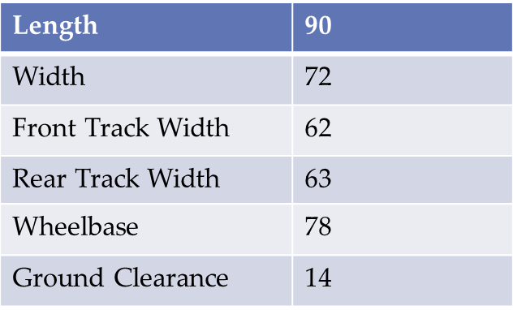

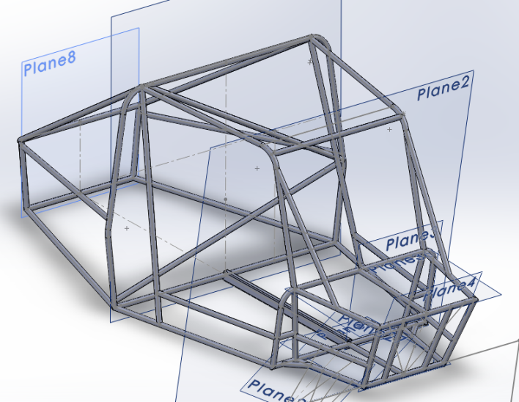

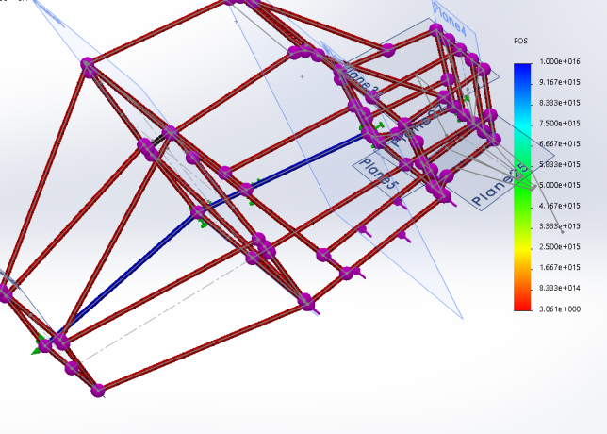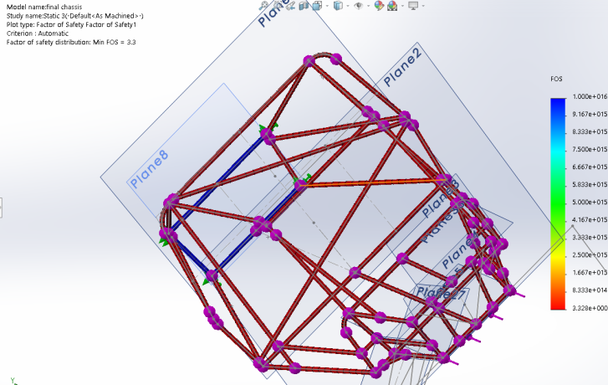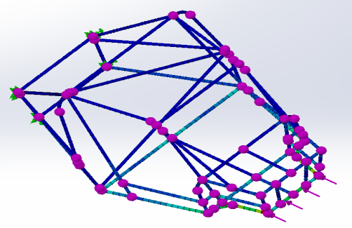

Analysis

|  |  |  |  |  |  |
| --- | --- | --- | --- | --- | --- |
| Analysis | Load | Deformation Scale | Displacement  mm | Stress  MPa | FoS |
| Front impact | 2.3G | 3 | 1.04 | 112 | 3.5 |
| Side impact | 1.2G | 3  ***Tech Specs*** | 1.7 | 94 | 3.3 |

Material selected : AISI 1018

Tyres (inches)

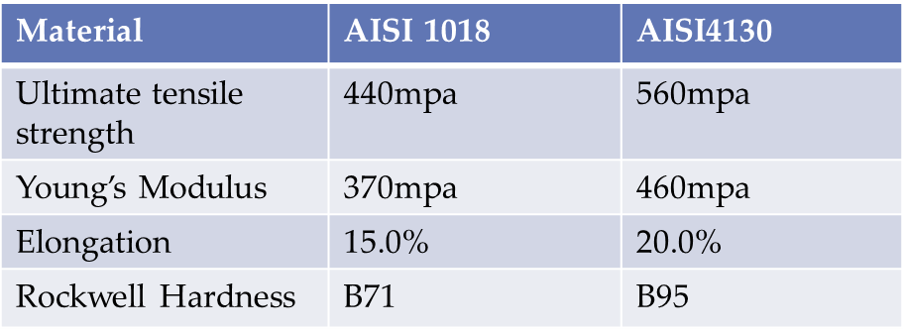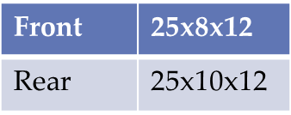

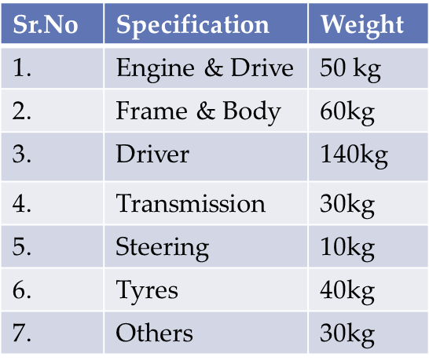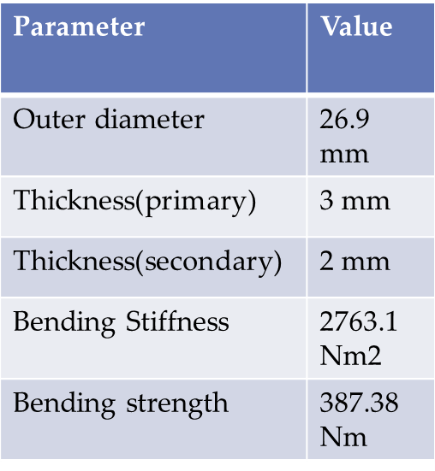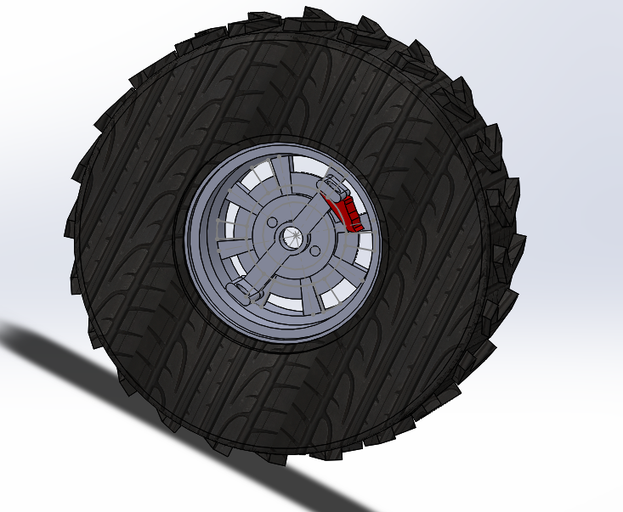

Tube Specifications

***Suspension***

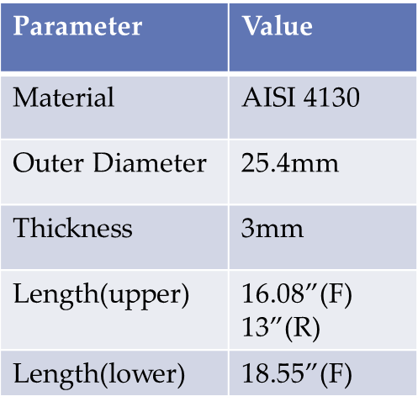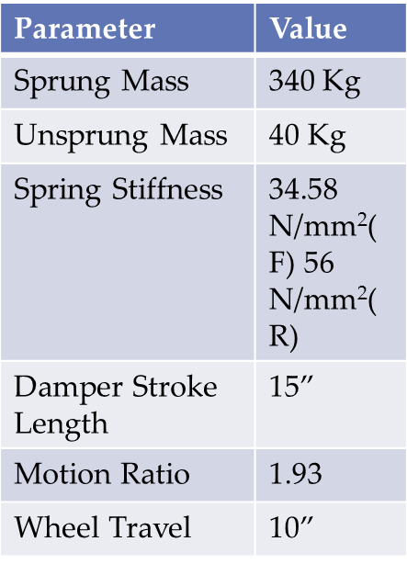 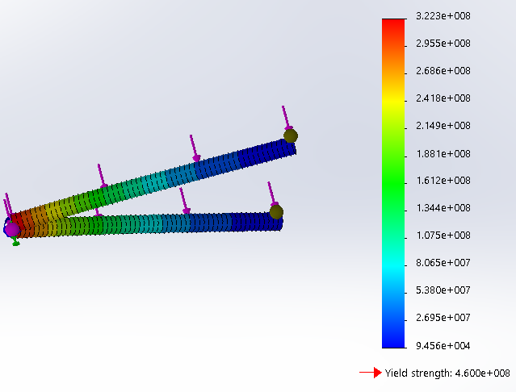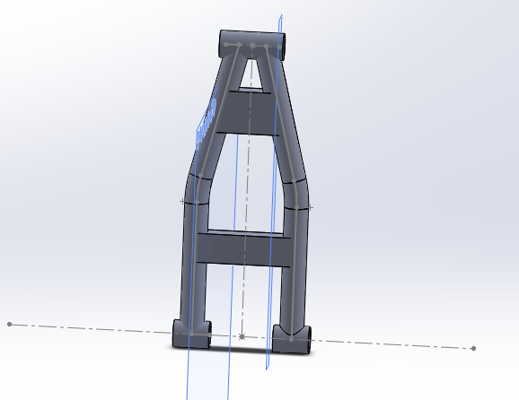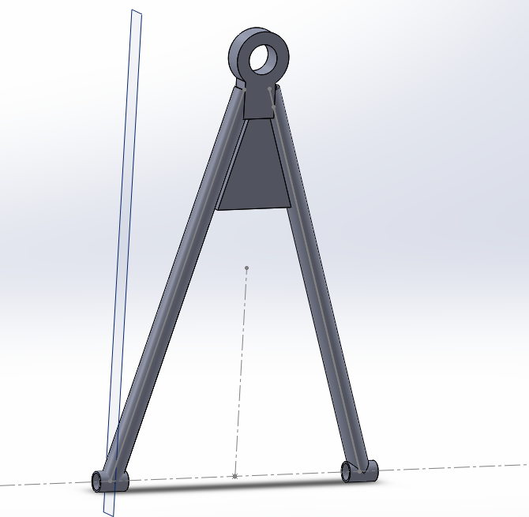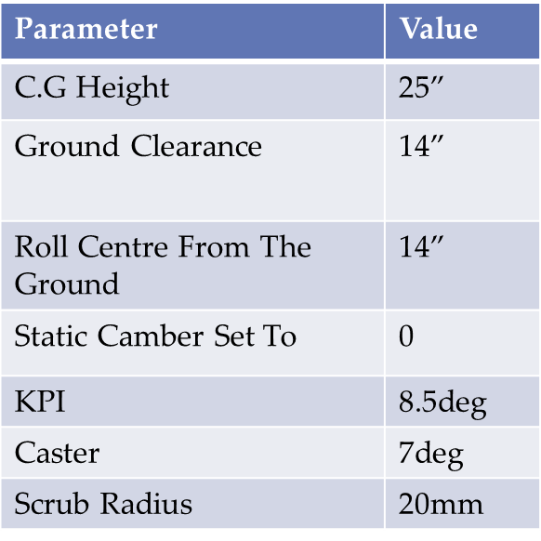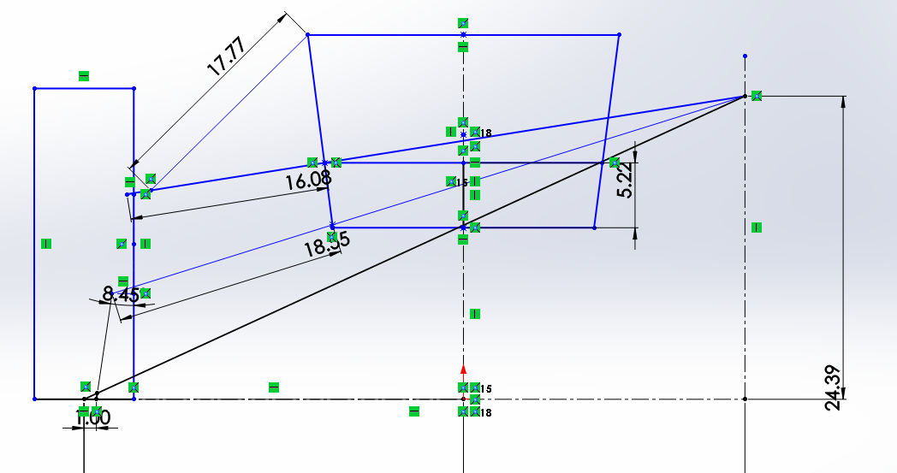

Analysis

Load-2000N

Stress-208MPa

FoS-2.1

***Braking system***

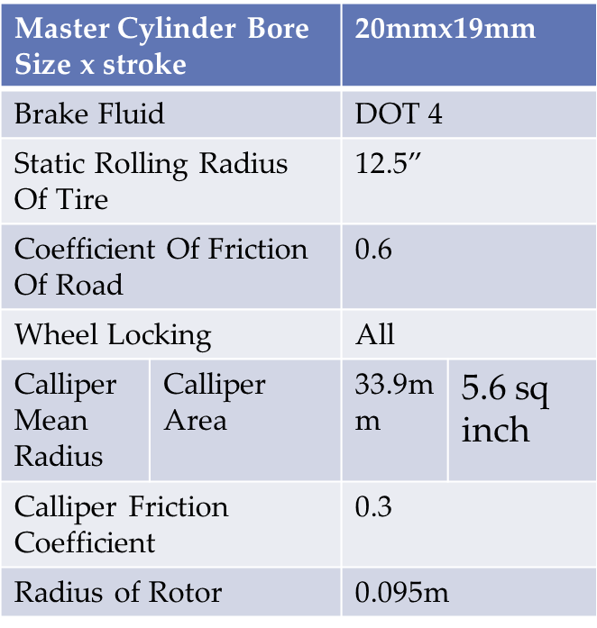

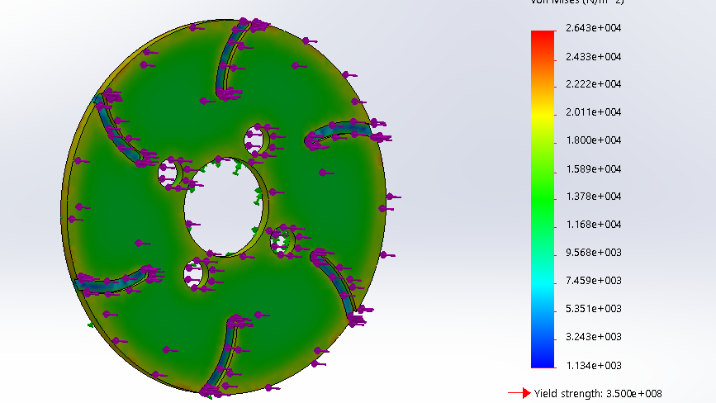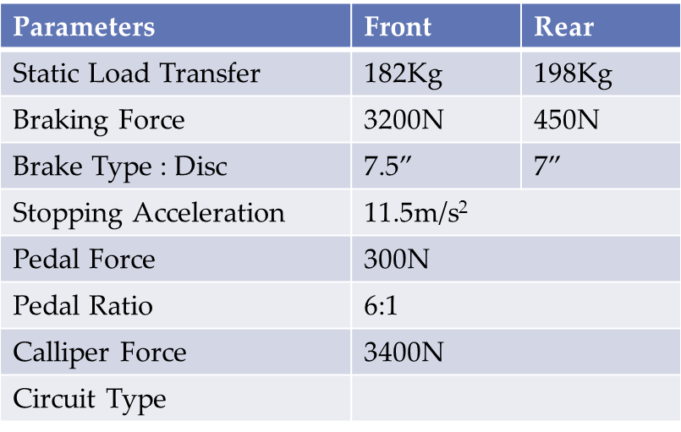

X split

**BRAKES USED:-**

**FRONT-DISC**

**REAR-DRUM**

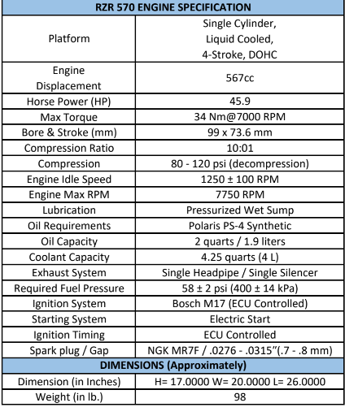

***Steering*** ***& Power Train***

|  |  |
| --- | --- |
| **Components** | **Data** |
| Rack | 6.3” |
| Pinion | 21 mm(dia) |
| Steering Wheel(dia) | 12” |
| Steering Column |  |
| Turning Radius | 3.5m |
| Ackerman | 60% |
| Steering Ratio | 8:1 |
| Scrub Radius | 20mm |
| Camber | -1.5deg |
| Caster | 6deg |
| Tie rod | 49” |

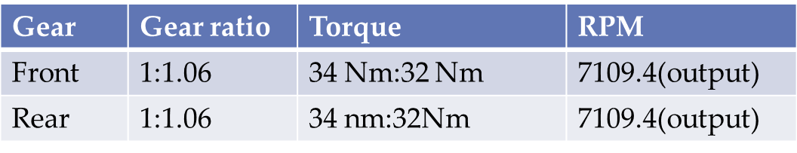

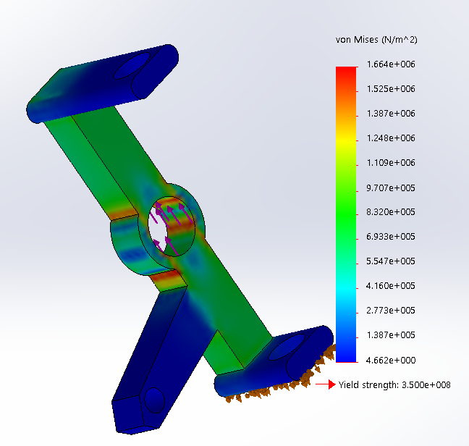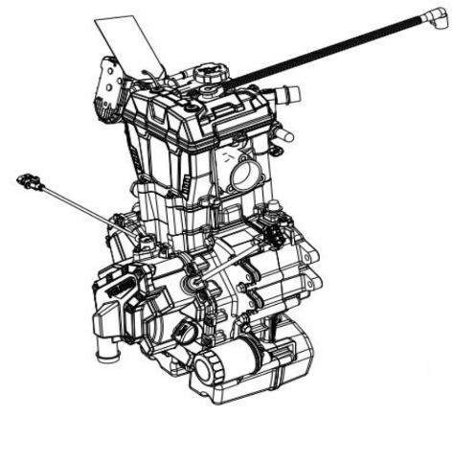

**Knuckle**

**Analysis-**

**Load-1500N**

**Stress-1.8MPA**

**SAFETY**

Utmost safety of driver is considered

Safety parameters:

* + Kill switch is used.
  + Cockpit switch is used.
  + Brake light switch is used.
  + Isi rated fire extinguishers mounted at the back.
  + Five strap system seating installed.
  + Fos of frame-
  + Single metal to metal quick release lever buckle is used.
  + Dead pedal is used.
  + An extra rod for navigator to hold upon is used.
  + Motorcross style helmet used for driver as well as navigator.
  + Handbrake is installed.
  + Strong LED headlights are used for proper coverage.

**CONCLUSION**

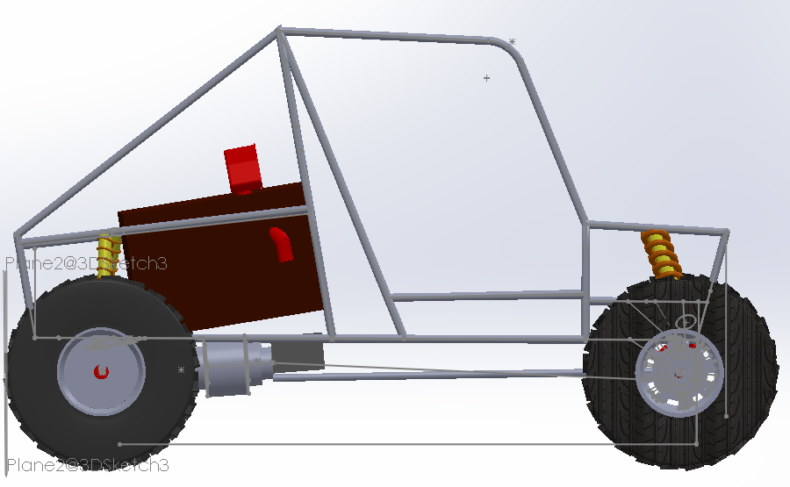

This report introduced a design for an off-roading car. We presented information about the engine , suspensions , brakes ,steering, materials, safety and accessories and provided sketches for our car. This car would be a good example of typical off-roading car optimised for the competition (RCDC).

**Acknowledgment**

**We would like to express our special thanks of gratitude to our teacher Dr.H.K.Govindraju (H.O.D Mech department) as well as our principal Dr. Mohan Babu who gave us the golden opportunity to do this wonderful project on the topic (RALLY CAR DESIGN CHALLENGE), which helped us gain practical knowledge in automotive field and we came to know about so many new things We am really thankful to them.Secondly we would also like to thank the whole team of RCDC who gave us this wonderful opportunity and we wish to do our best.**

**Annexure**